Library management system

Test Case: Card verification

TC01

**Version History**

|  |  |  |  |
| --- | --- | --- | --- |
| **Version** | **Date** | **Description** | **Author** |
| 1.0 | 1/10/2016 | Initial version | KAMAL RAJ KANDEL |

|  |  |
| --- | --- |
| **Test Case ID** | **TC01** |
| **Test Case Name** | Card verification. |
| **Description** | This test case tests the process that the user must swipe the correct library member Id card in order to borrow the books. It tests the following possible scenarios:   * User swipe the correct member ID card(TS01_01) * User swipe the wrong card (TS02_02) * User enter the negative integer as a member ID(TS0_03) |
| **Pre-Conditions** | User have to be the member of library. |
| **Post-Conditions** | System displays loan history of the user if exist and allow to scan the books. |

|  |  |
| --- | --- |
| **Data Required** | |
| Member ID | Integer type starting from 1 to 6 |

# Test script

**Version History**

|  |  |  |  |
| --- | --- | --- | --- |
| **Version** | **Date** | **Description** | **Author** |
| 1.0 | 1/10/2016 | Initial version | KAMAL RAJ KANDEL |

## The following test script were evaluated to test the Card verification test case.

## 

|  |  |
| --- | --- |
| **Test ID:** | **TS01_01** |
| **Test Name:** | **User swipe the correct card** |
| **Use Case Tested:** | Borrow books |
| **Test Description:** | Test how the system responds when the user swipes the correct card. |
| **Pre-conditions:** | The user must have the library member card. |
| **Post-conditions:** | System display the user loan history details. |
| **Notes:** | The member id should be correct. |
| **Result**  **(Pass/ Fail/ Warning/ Incomplete)** |  |

|  |  |  |  |  |
| --- | --- | --- | --- | --- |
| **Step Number** | **Test Step** | **Expected Test Results** | **Pass** | **Fail** |
| **1.** | User click on borrow books. | System display the card reader forum. |  |  |
| **2.** | User swipes the card | System display the user loan history. |  |  |

|  |  |  |  |  |  |  |
| --- | --- | --- | --- | --- | --- | --- |
| **Test Data Table** | | | | | |  |
|  | 1 | 2 | 3 | 4 | 5 | 6 |
| Member ID | 1 | 2 | 3 | 4 | 5 | 6 |

# Result On The Screen

## Result for Member ID 1

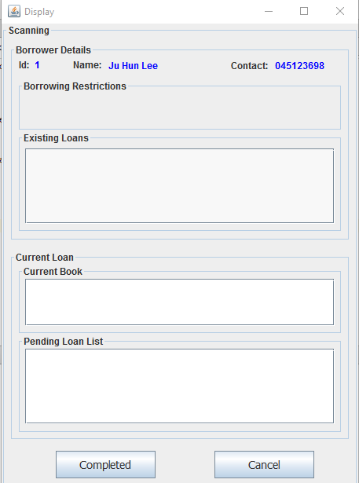

## Result for Member ID 2

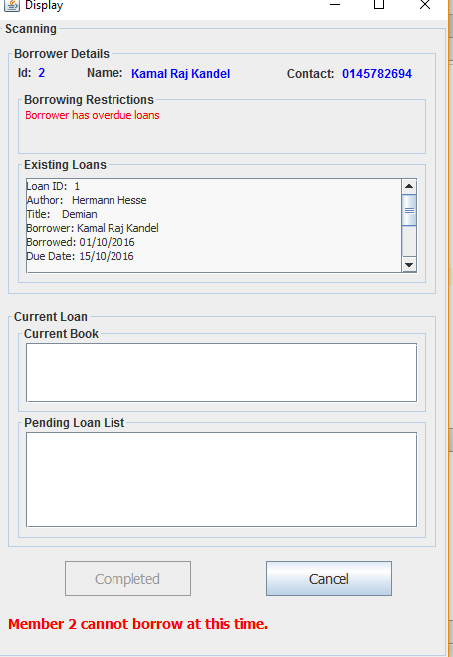

## Result for Member ID 3

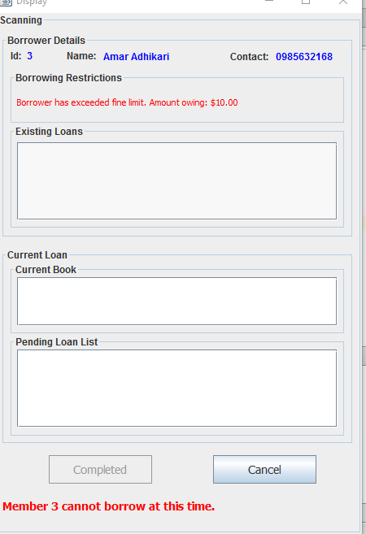

## Result for Member ID 4

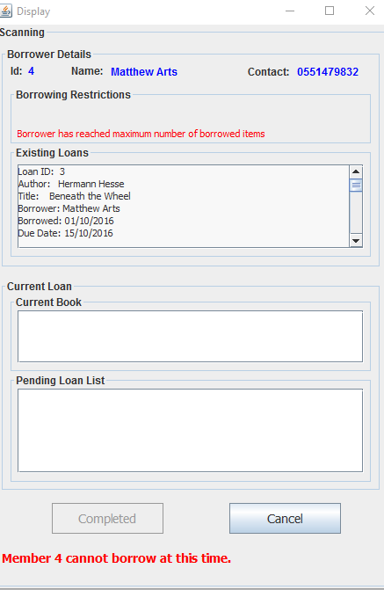

## Result for Member ID 5

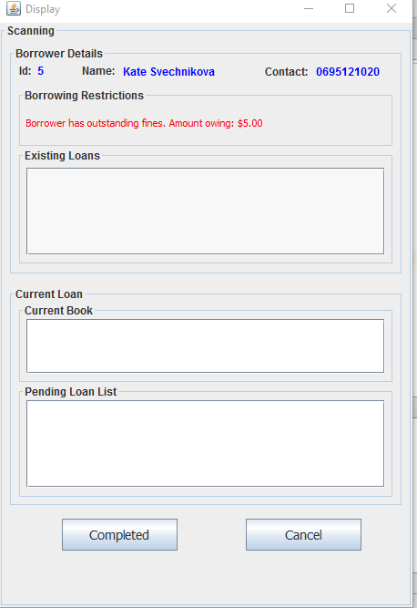

## Result for Member ID 6

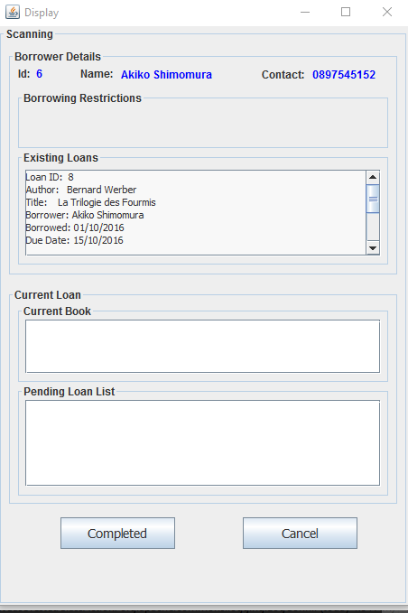

|  |  |
| --- | --- |
| **Test ID:** | **TS02_02** |
| **Test Name:** | **User swipe the wrong card** |
| **Use Case Tested:** | Borrow books. |
| **Test Description:** | Test how the system responds when the member swipes the wrong card. |
| **Pre-conditions:** | * The user must have the library member card. |
| **Post-conditions:** | * System display member not found message. |
| **Notes:** | The member id should be correct. |
| **Result**  **(Pass/ Fail/ Warning/ Incomplete)** |  |

|  |  |  |  |  |
| --- | --- | --- | --- | --- |
| **Step Number** | **Test Step** | **Expected Test Results** | **Pass** | **Fail** |
| **1.** | User click on borrow books. | System display the card reader forum. |  |  |
| **2.** | User swipes the card | System display the Member not found message. |  |  |

|  |  |  |  |  |  |  |
| --- | --- | --- | --- | --- | --- | --- |
| **Test Data Table** | | | | | |  |
|  | 1 | 2 | 3 | 4 | 5 | 6 |
| Member ID | 7 | 8 | 9 | 10 | 11 | 12 |

# Result on the Screen

## Result for Member ID 7

## 

## RESULT FOR MEMBER ID 8

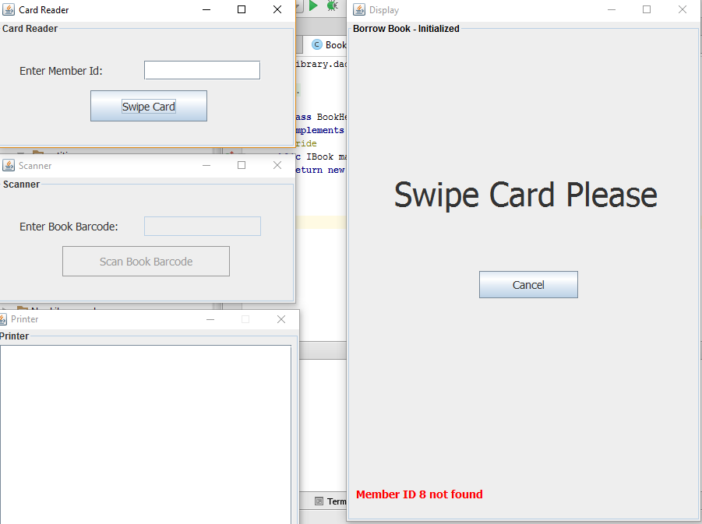

## RESULT FOR MEMBER ID 9

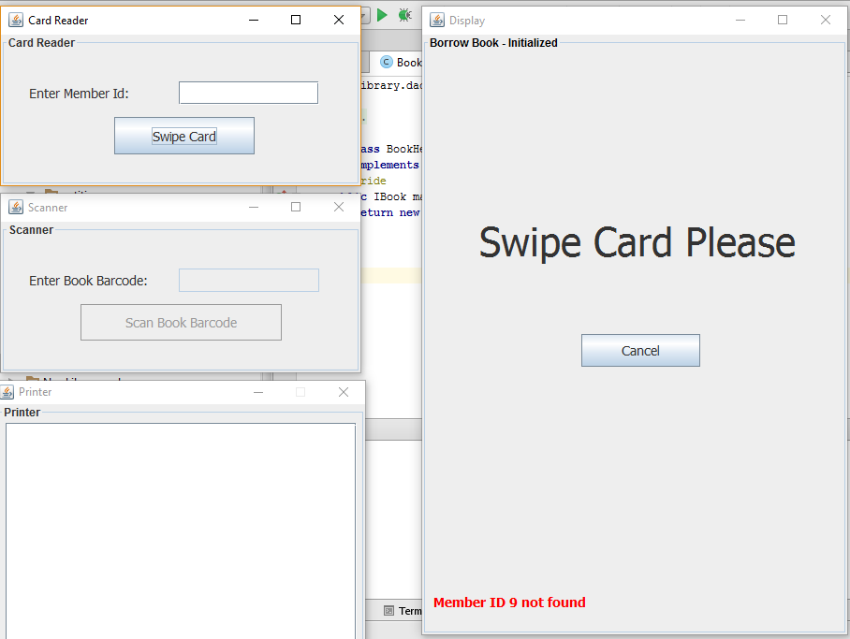

## RESULT FOR MEMBER ID 10

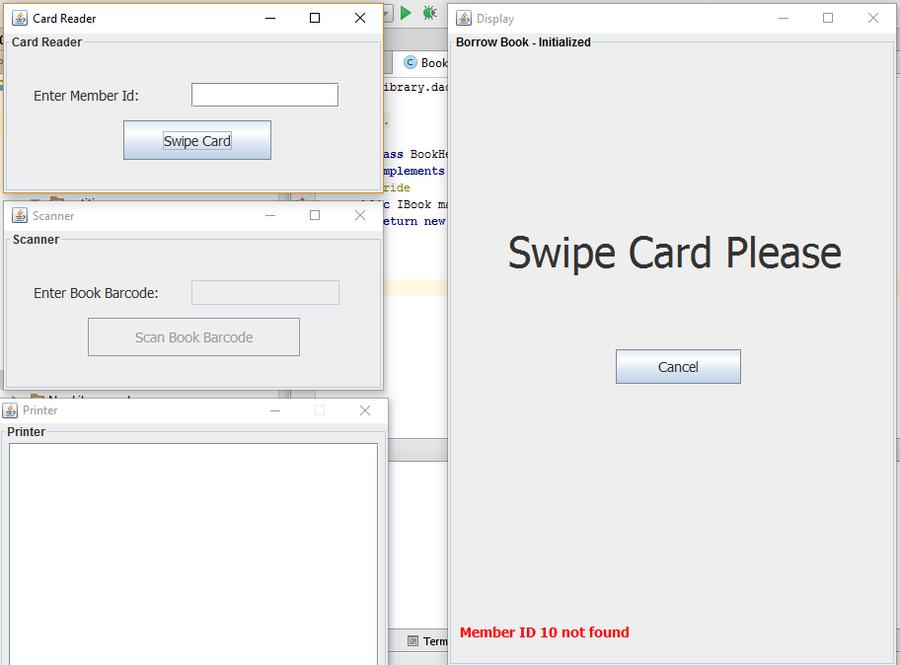

## RESULT FOR MEMBER ID 11

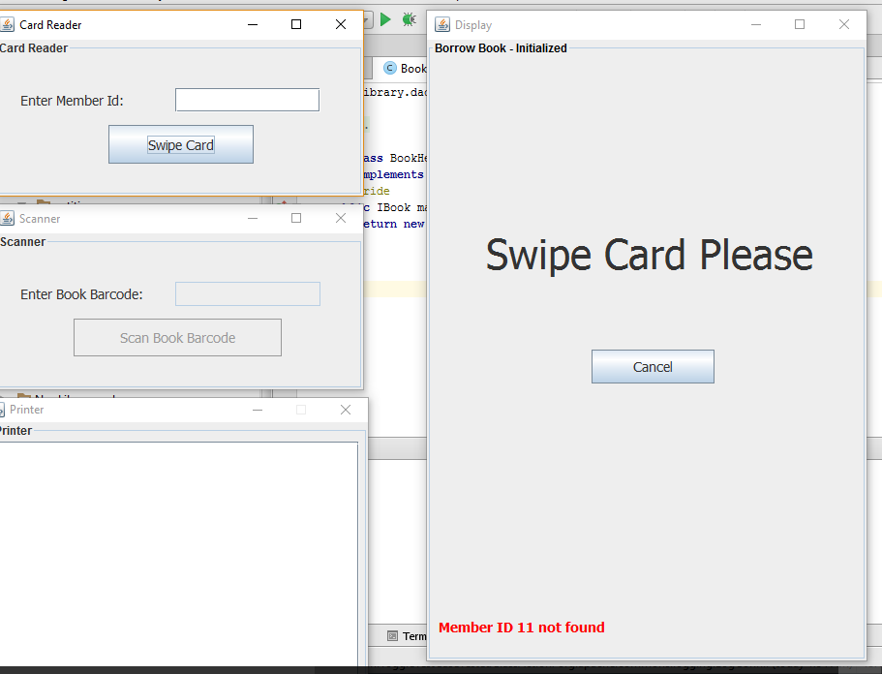

## RESULT FOR MEMBER ID 12

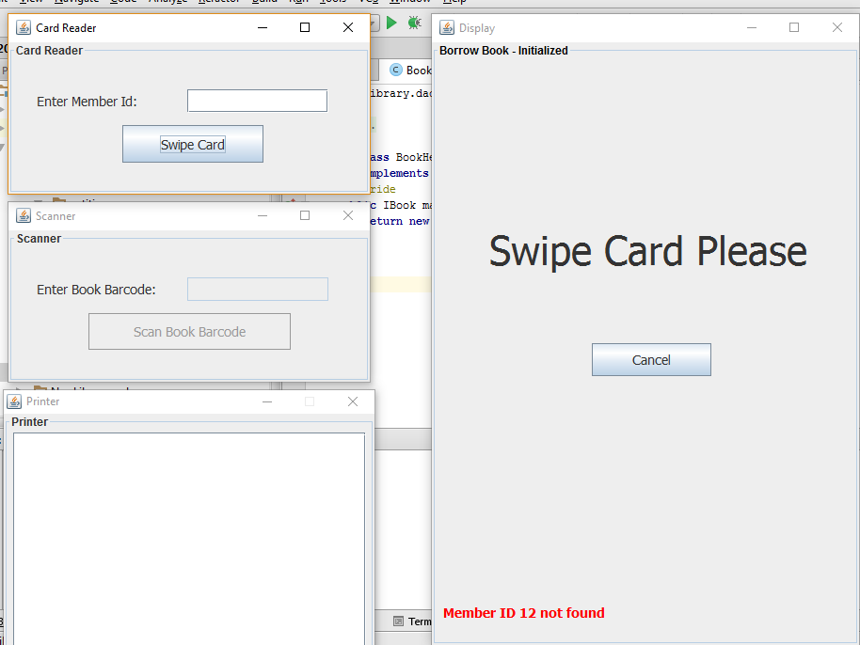

## 

|  |  |
| --- | --- |
| **Test ID:** | **TS03_03** |
| **Test Name:** | **User enter the negative integer as member id or just simply enter swipe card without filling the text field of member id.** |
| **Use Case Tested:** | Borrow books |
| **Test Description:** | Test how the system responds when the user provides the negative integer as a member id |
| **Pre-conditions:** | The user must have the library member card. |
| **Post-conditions:** | System display the member id must be positive integer. |
| **Notes:** | The member id should be correct. |
| **Result**  **(Pass/ Fail/ Warning/ Incomplete)** |  |

|  |  |  |  |  |
| --- | --- | --- | --- | --- |
| **Step Number** | **Test Step** | **Expected Test Results** | **Pass** | **Fail** |
| **1.** | User click on borrow books. | System display the card reader forum. |  |  |
| **2.** | User enter the negative integer or leave empty. | System display the member id cannot be negative. |  |  |

|  |  |  |  |  |  |  |
| --- | --- | --- | --- | --- | --- | --- |
| **Test Data Table** | | | | | |  |
|  | 1 | 2 | 3 | 4 | 5 | 6 |
| Member ID | -1 | -2 | -3 | -4 | -5 | -6 |

# 

# Result on the screen

